Supplementary material

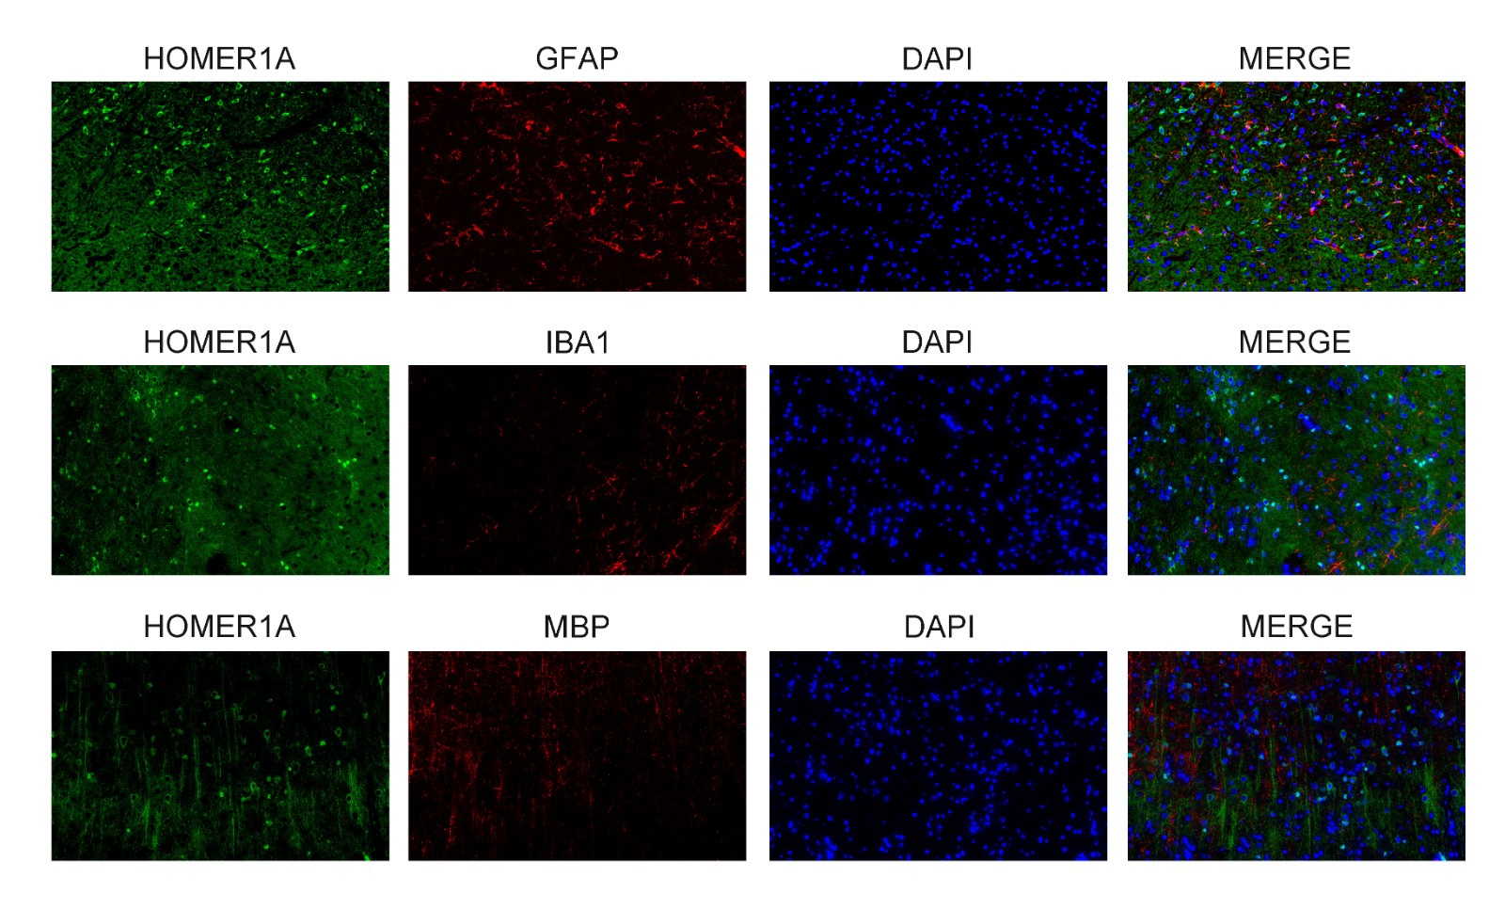
Supplementary Fig. 1. The co-stains of HOMER1A and cell type-specific markers (e.g., IBA1 for microglia, GFAP for astrocytes, MBP for myelin sheath cells) were detected through IF assay.

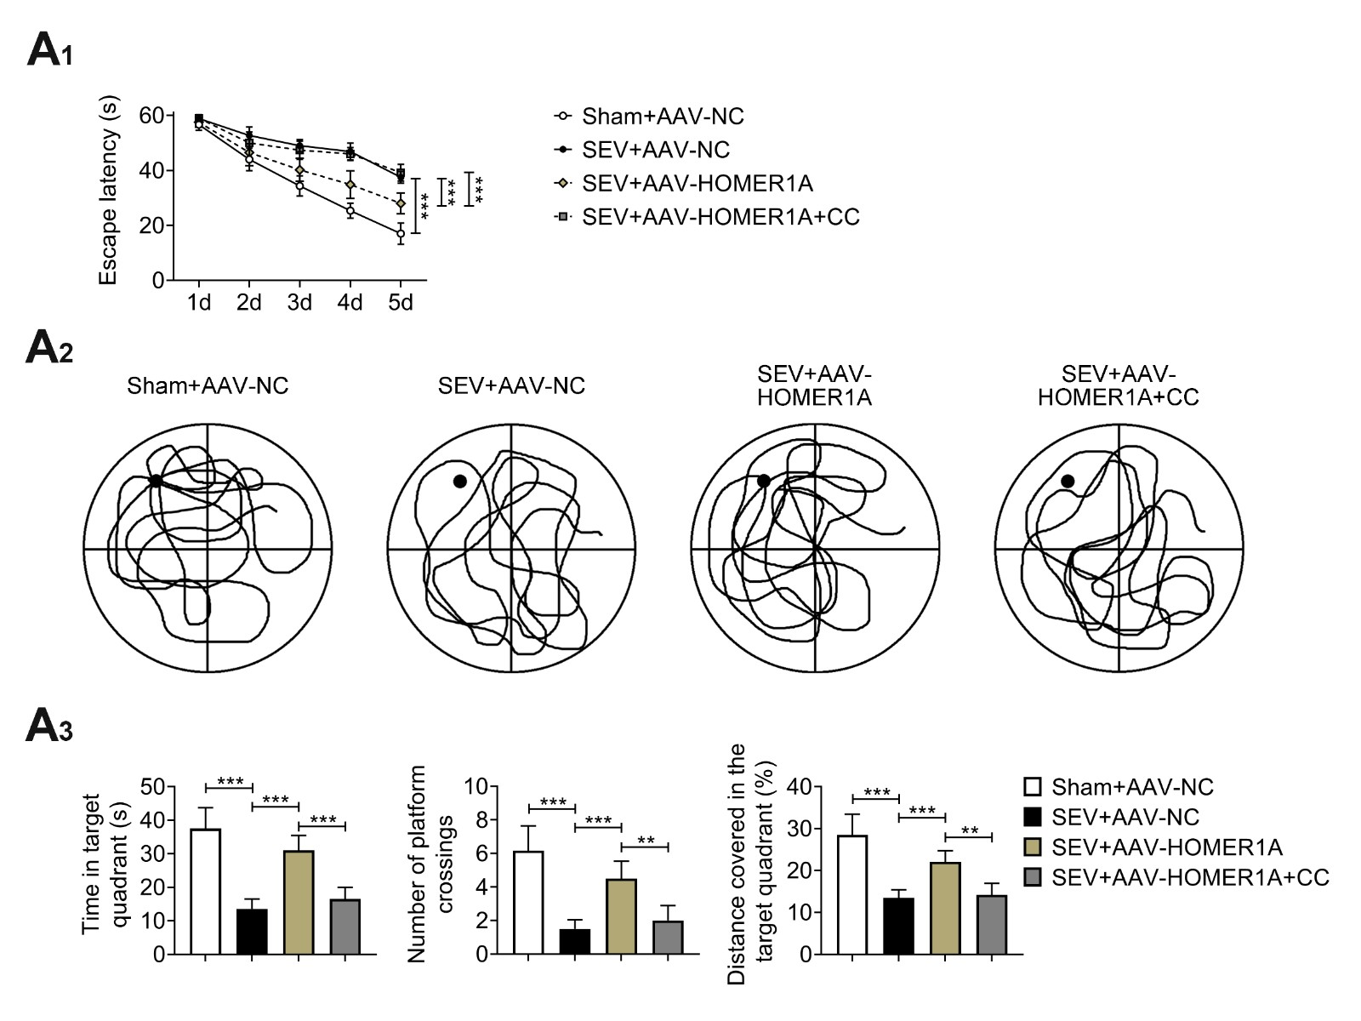
Supplementary Fig. 2. Groups were divided into the Sham, SEV + AAV-NC, SEV + AAV-HOMER1A and SEV + AAV-HOMER1A + CC (AMPK inhibitor) group. The Escape latency, Clutter level of path, Time in target quadrant, Number of platform crossings, Distance covered in the target quadrant were assessed through Morris water maze test. **p < 0.01, ***p < 0.001.

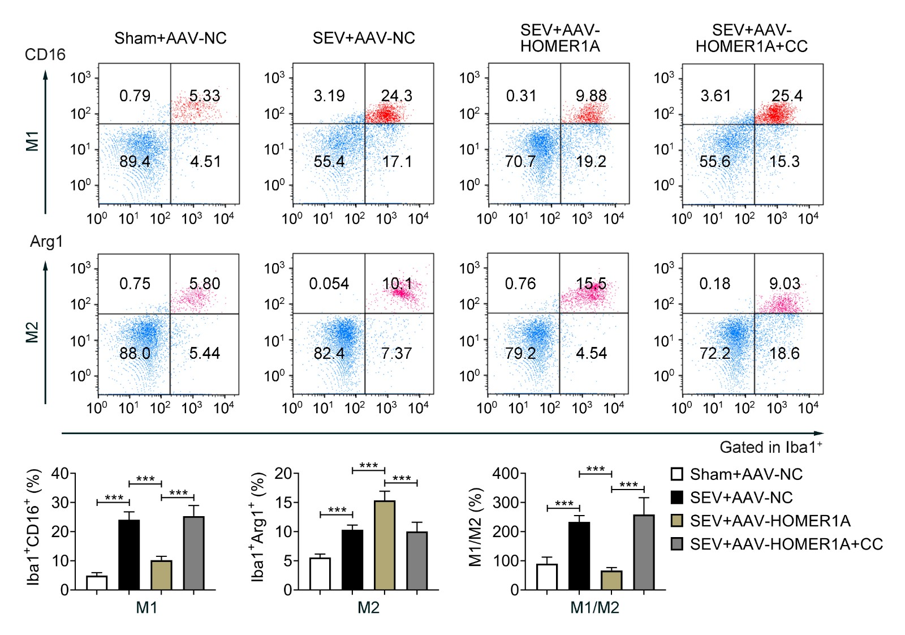
Supplementary Fig. 3. Molecular mechanism of HOMER1A-AMPK/TXNIP axis in SEV-stimulated cognitive dysfunction. HOMER1A activates the AMPK/TXNIP axis to regulate microglia M1/M2 imbalance and cognitive defect in SEV-stimulated cognitive dysfunction. Groups were divided into the Sham, SEV + AAV-NC, SEV + AAV-HOMER1A and SEV + AAV-HOMER1A + CC (AMPK inhibitor) group. The M1 (Iba1⁺ CD16⁺) and M2 (Iba1⁺ Arg1⁺) cells were confirmed through flow cytometry. ***p < 0.001.

